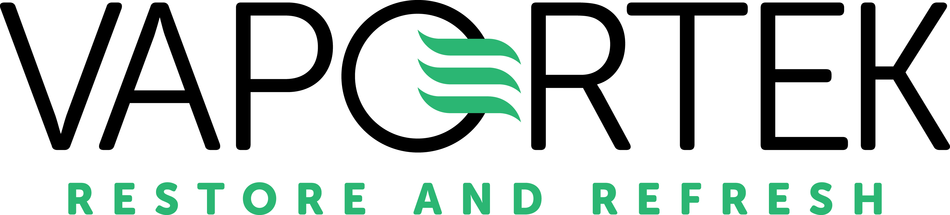

Vaportek New Private Label Program

Nature Fresh Mini & Max Odor Neutralizers

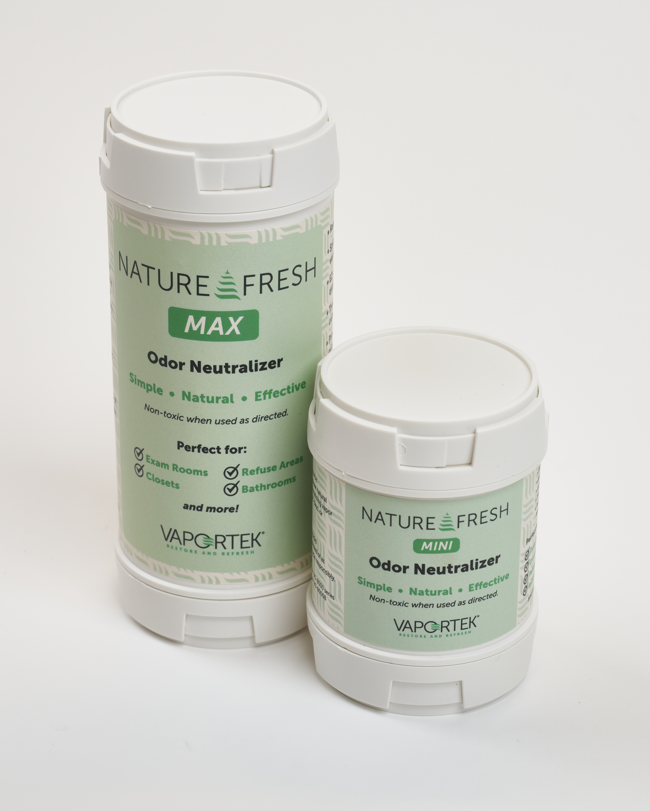

Why Private Label?
This is your chance to showcase your brand in a powerful, practical way. The Nature Fresh Mini and Max are proven odor control solutions—now available to carry *your* name. Whether you’re leaving a lasting impression after a job or promoting your company through value-added service, our private label program makes it easy to offer a unique, professional product that reinforces your brand identity every time it's used.

What You Can Offer
- Nature Fresh Mini – 3" Cartridge
- Nature Fresh Max – 5" Cartridge
Choose from three great scents: Neutral, Winter, or Linen
(Just one fragrance per program to keep things streamlined and efficient.)

Custom Branding
- Your logo and design featured on the outer label
- Comes in cases of 12 units (1 dozen)
- We’ll create your label for you (free with commitment!) or use your provided artwork*

Getting Started
Opening Order:
Start with just 12 cases total across Mini or Max (all in the same fragrance)
(For example: 6 Mini + 6 Max — all Linen scent)
Ongoing Commitment:
1-Year Plan
- At least 50 cases per size over 12 months
- Orders placed at least every 6 months
- Includes free label design and ground shipping (U.S.)
2-Year Plan
- At least 80 cases per size over 24 months
- Orders placed at least every 6 months
- Includes free label design and ground shipping (U.S.)
Note: If you don’t meet your agreed forecast, you’ll cover the cost of remaining pre-printed sleeves. $3,000 total minimum spend required to maintain private label pricing and perks.

Pricing Snapshot
Product | 1-Year Plan | 2-Year Plan
Nature Fresh Mini | $63.00/dozen | $59.85/dozen
Nature Fresh Max | $85.00/dozen | $80.55/dozen
*Includes full-color private label sleeve. Extra charges may apply for non-standard artwork or packaging.*

Quick Turnaround
- New labels approved in 3–4 weeks
- Reorders ship in just 1–2 weeks
- We keep your labels on file for easy reprints

Simple Terms
- Shipping included with commitment plan
- Net 30 terms (with approved credit)
- We’ll help with label artwork or accept your files and provide proof for “sign off” before production

Extra Perks When You Commit
- ✅ Free label design (no setup fees!)*
- ✅ Free ground shipping in the U.S.
Perks apply once commitment form is signed and order minimums are met.

Next Steps
1. Approve your label (or let us design it!)
2. Place your first order (12-case minimum)
3. Pick your forecast plan (1 or 2 years)
4. We handle the rest!
Ready to give your brand a boost? Let’s make it happen.
Reach out today:
Nic Fugate
Key Accounts Manager
nic@vaportek.com
(800) 237-6367 ext. 230

* Design services are limited to (2) rounds of proofs. Logo artwork must be supplied in acceptable format. If additional revisions are required, labor will be billed at $150.00/hour.

